CHC30113
Certificate III
Early Childhood Education and Care
Student Resource

CHCECE004
Promote and provide healthy food and drinks

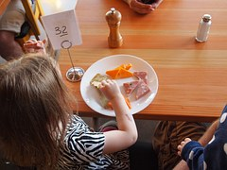

Meal times in a childcare centre are a hive of activity. Children look forward to seeing what is on the menu and eating. It’s a time for socialisation, learning new skills and trying new things. Many children in Australia are spending more and more time in a care environment. This means that many children are eating away from home. As educators, we have to ensure that the food we provide is healthy, appropriate and safe.

Promoting healthy food and drink

Children who are in care are always learning. Childcare is more than just a place for children to be cared for. In fact, as educators we are doing more than caring, but we also educating children. It is important that when it comes to promoting food and drink in our child care centre, we need to make sure that children are actively involved. The best way to do this, is to get them involved in decision making.

The first step is active consultation. You can consult with the children about what they like to eat. You can do a survey with families as well. This will give you a better idea as to what children like and dislike and also what families would like to see on the menu. Don’t forget families are just as important as the children!

Engage children in conversations about food and drink. This is a great time to get to know the children at your centre. It is important that the focus does remain on health and nutrition, and that as an educator we encourage healthy eating habits. We need to remind children the benefits of healthy food and drink.

Something to think about
Think back to being a child, what was it about food and drink choices that excited you? How can you bring that excitement into a child care environment?

Another fun way to promote food and drink is to make it in to an activity. Think about incorporating cooking in to your learning experiences. Get children involved in making a meal to share at child care. As an educator take notes as part of your observation process on what children are saying about food and drink. Use these observations to extend your learning program.

As early childhood educators, we need to be aware of the Australian healthy eating guidelines. To be aware of theses practices will enable us to make sure that the information we are giving children and families is correct and up to date.
The below picture demonstrates the Healthy eating guidelines that we should be implementing in our centres.

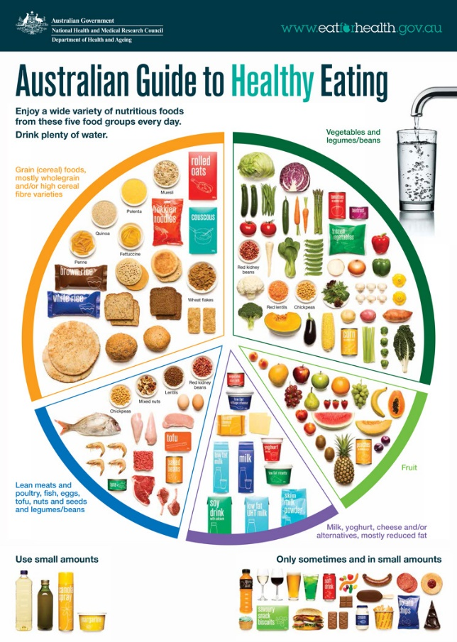

During meal times, sit with the children and eat with the children. This will encourage children to also do the same. As educators we have the responsibility to model what we expect from the children who are in our care. Childcare environments should be set up in such a way that they are inviting to children. This is also true when it comes to meal times. Children should always have access to water. If children are using their own water bottles, ensure that they are labelled with the child’s name and that children know where to access them. Sometimes just having small table in the corner of a room, with the water bottles on it, is accessible to children.

Children in a childcare environment are always active. They are playing and learning all of the time. As a result, it is not unusual for them to get hungry often. The best way to overcome this is to offer children healthy snacks throughout the day. This can be as simple as cutting up fruit and offering it as a platter (this gives children a choice of what fruit they would like to eat) or you could offer vegetables and dips or even crackers and cheese. Some child care centres have a designated dining room, while others will modify a space to accommodate meal times.
Whichever way you decide, the environment must be child friendly and encourage children to be positively involved in meal times. Tables, plates, cups, cutlery all have to be accessible and easy for children to use. You can purchase child friendly equipment at most homeware stores. Some examples of child friendly utensils are :

Sippy cups for toddlers Easy to grip cutlery

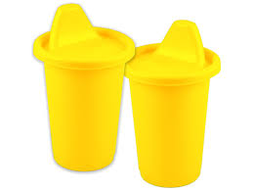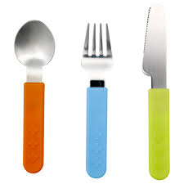

Bowls and plates that are easy to hold Chemical free plastic utensils
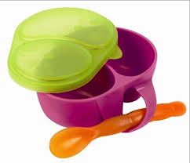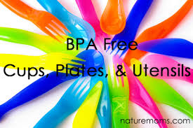

The furtiure should be suited to the age of the childrens . You don’t want high tables and tall cheairs that chidren can reach. For younger children you will need to have high chairs. Bright colours are also inviting.

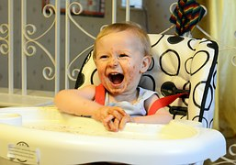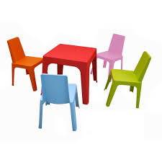

Healthy Eating Guidelines

Food is very important in maintaining health and development. This is especially true for children. If children are not give the correct nutrients they could develop health issues. If children are not taught about healthy food options form a young age, this could lead to unhealthy food habits later in life.

In Australia we have guidelines to assist us in ensuring that the food and drinks we are consuming are consistent with information gained from health professionals. As educators, we have to follow these guidelines when it comes to providing food a drink to children who are in our care. The guidelines differ for each age group, so its best practice to be mindful of this when menu planning in your centre.

The five main guide lines for healthy eating in Australia are :
Guideline 1
To achieve and maintain a healthy weight, be physically active and choose amounts of nutritious food and drinks to meet your energy needs
- Children and adolescents should eat sufficient nutritious foods to grow and develop normally. They should be physically active every day and their growth should be checked regularly.

- Older people should eat nutritious foods and keep physically active to help maintain muscle strength and a healthy weight.
Guideline 2
Enjoy a wide variety of nutritious foods from these five groups every day:
- Plenty of vegetables, including different types and colours, and legumes/beans
- Fruit
- Grain (cereal) foods, mostly wholegrain and/or high cereal fibre varieties, such as breads, cereals, rice, pasta, noodles, polenta, couscous, oats, quinoa and barley
- Lean meats and poultry, fish, eggs, tofu, nuts and seeds, and legumes/beans
- Milk, yoghurt, cheese and/or their alternatives, mostly reduced fat (reduced fat milks are not suitable for children under the age of 2 years)
And drink plenty of water.

Guideline 3
Limit intake of foods containing saturated fat, added salt, added sugars and alcohol
a. Limit intake of foods high in saturated fat such as many biscuits, cakes, pastries,
pies, processed meats, commercial burgers, pizza, fried foods, potato chips,
crisps and other savoury snacks.
- Replace high fat foods which contain predominantly saturated fats such as butter, cream, cooking margarine, coconut and palm oil with foods which contain predominantly polyunsaturated and monounsaturated fats such as oils, spreads, nut butters/pastes and avocado.
- Low fat diets are not suitable for children under the age of 2 years.
b. Limit intake of foods and drinks containing added salt.
- Read labels to choose lower sodium options among similar foods.
- Do not add salt to foods in cooking or at the table.

c. Limit intake of foods and drinks containing added sugars such as confectionary, sugar-sweetened soft drinks and cordials, fruit drinks, vitamin waters, energy and
sports drinks.
d. If you choose to drink alcohol, limit intake. For women who are pregnant, planning a pregnancy or breastfeeding, not drinking alcohol is the safest option.
Guideline 4
Encourage, support and promote breastfeeding
Guideline 5
Care for your food; prepare and store it safely
Reference : ( https://www.eatforhealth.gov.au/guidelines/australian-dietary-guidelines-1-5)

Remember when preparing food for children, make sure that you read the labels to ensure the food you are serving is healthy and prepared according to directions.
It’s also a great idea to display posters around your centre about healthy eating guidelines. This is one way of informing parents. Your centre should also have a nutrition policy.

All Children are different. They like different foods, have different tastes and in some cases have allergies. As an educator it is important that you take this in to account as well as any cultural needs. Take time to learn about the children that are in your care. It is your duty of care and an educator to be aware of any special needs. A good idea is to check the child’s enrolment form and take note of any special dietary requirements. Childcare centres will have an easily accessible list of children who have allergies and dietary requirements so that it is easy for the educators to keep informed.

To keep families informed it’s a great idea to place some easy to read flyers in reception. By doing this you are educating families about healthy eating guidelines. Its also a way of bridging the gap between home and childcare as the aim is to educate families so that they follow healthy eating guidelines at home.

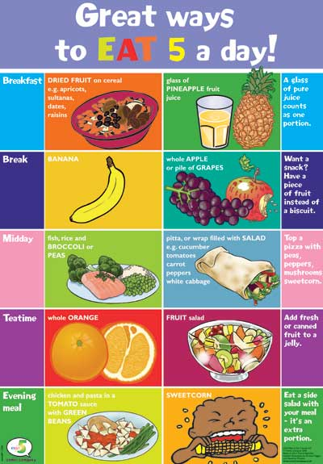

Menu planning

Children love to see what’s on the menu when it comes to meal times in childcare. Menus should be on display for all families and children to read. The menu should be made in consultation with children, families and staff. It is important to consider children who have dietary requirements such as allergies. When it comes to menu planning, it is good practice to have food that will appeal to all children. If you have children who have allergies or can only eat certain foods due to cultural reasons, it’s a good idea to offer and alternative for those children. After all a child care environment is meant to be inclusive.
Your menu plan could look something like this:
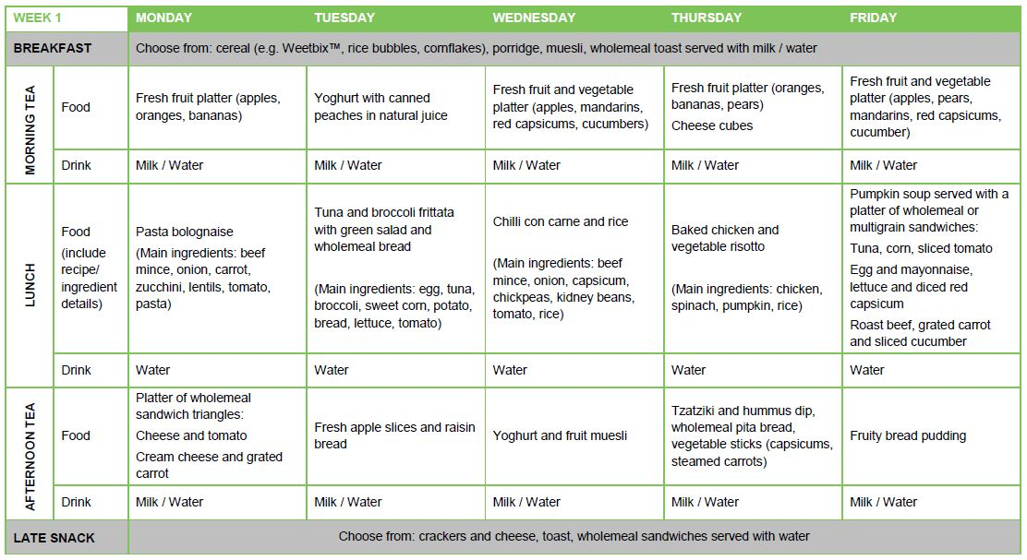

Food safety

In a childcare centre we have to be mindful of food safety. What we do at home may not always be best practice. It is our duty of care to ensure that the food we are serving is prepared in a safe way. We have to follow the Australian Guidelines for food safety when we prepare food in a licenced children’s service. In every childcare centre the cook will have their food handlers certificate. This does not mean that it is only up to them to maintain food hygiene, but it is everyone’s responsibility. Those with food handing certificates are there to help supervise the preparation of food.

Food poisoning can be dangerous to small children. Food poisoning occurs when bacteria grows. Food can be classed as low risk or high risk. Some examples of high risk food are:

- Meat
- Poultry
- Eggs
- Dairy products

It is important that all foods including high risk foods are not left to sit in the temperature danger zone (between 5 degrees and 60 degrees Celsius).

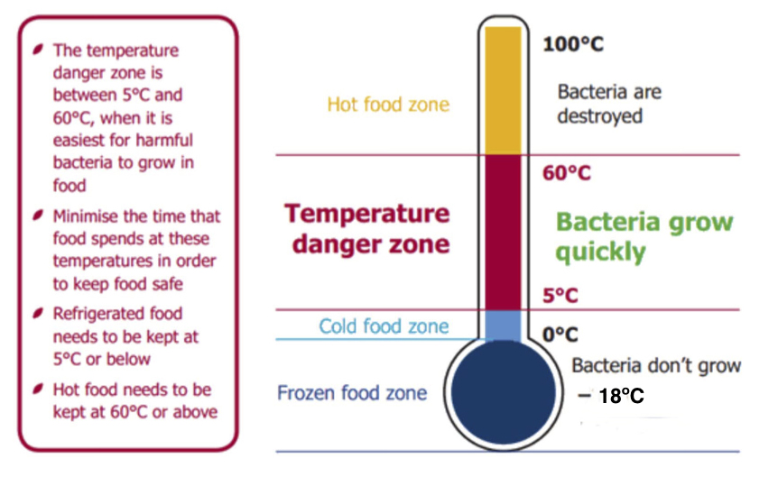

It’s also important that any food that is refrigerated is kept at a temperature between 5 degrees and 0 degrees.

The best ways to keep food safe and to maintain food safety and hygiene is to follow these rules:

- Keep raw food separate from cooked and ready-to-eat food to prevent cross contamination
- Use different knives, chopping boards or other equipment for raw and cooked or ready-to-eat food. If this is not possible, equipment must be thoroughly washed in hot soapy water between uses
- Thoroughly rinse fruit and vegetables in clean water
- Use clean sanitised utensils (tongs, spoon, spatula) to serve cooked or ready-to-eat food
- Use only clean, disposable gloves and change them at least once every hour
- Store food in a container that is clean, non-toxic and strong enough to hold the contents

At no point should sick staff be asked to handle food. Virus and illnesses can travel though food preparation and thus make children and another staff sick. So if your sick stay away!!

Sometimes parents may bring in food for their children from home. This is particularly true for family day care. It is important that this food is sorted correctly and that children do not share food. This is because children might have allergies .

Food that has come from a child’s home also needs to be stored according to food safety standards. Food must be stored in the correct places eg fridge, freezer, pantry. Don’t leave food in the child’s bag or sitting on a bench.

Hand washing
Washing your hands is a very important step in preventing the transmission of viruses and illnesses.

- Handwashing should be done :
- Before preparing food
- After preparing food
- When handling raw and cooked products
- After going to the bath room
- After blowing your nose

To wash your hands effectively you need to do the following:

- Wet hands
- Lather with soap
- Rub hands for 20 seconds
- Make sure you are cleaning between fingers and under finger nails
- Rinse hands
- Dry hands

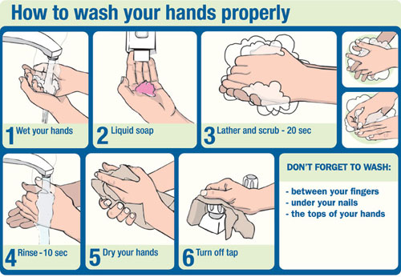

It is important that all staff and children follow the correct hand washing procedure.

